Assignment -4

|  |  |
| --- | --- |
| Assignment Date | 14 NOVEMBER 2022 |
| Student Name | Bava dharani |
| Role | Team member |
| Student Roll Number | 912319104003 |
| Maximum Marks | 2 Marks |
| Team ID | PNT2022TMID48008 |

# Question-1:

Pull an Image from docker hub and run it in docker playground.

|  |
| --- |
| **Solution:** |
| * Pull an image *uifd/ui-for-docker* from the docker hub * This image is used for viewing and managing the docker engine * Use docker pull image_name and docker run -it image_name commands to * run the above image in the Docker Playground |
|  |

# Question-2:

Create a docker file for the jobportal application and deploy it in Docker desktop application.

# Solution:

* Create a docker file for build and deploy flask app.
* Use docker build -t image_name . in the current directory to start building the
* docker image and deploy in our local docker
* Use docker run -p 5000:5000 image_name to run in local system

# CODE

FROM ubuntu/apache2 FROM python

COPY ./requirements.txt /flaskApp/requirements.txt WORKDIR /flaskApp

RUN pip install -r requirements.txt COPY . /flaskApp

ENTRYPOINT [ "python" ] CMD ["app.py" ]

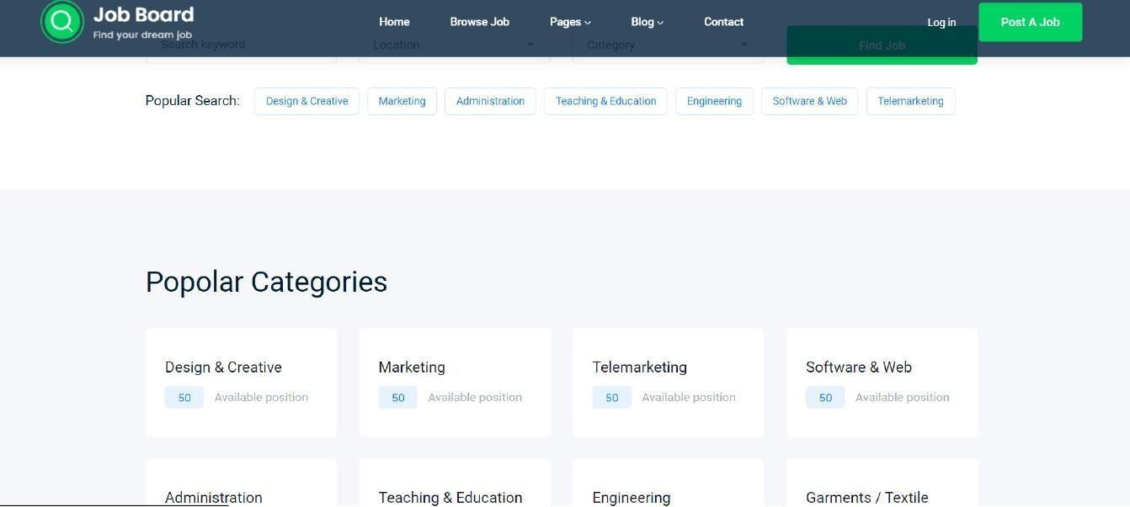

# Question-3:

Create a IBM container registry and deploy hello world app or job portal app.

# Solution:

* Log into IBM cloud
* Create a container registry
* Using IBM Cloud CLI, install the container registry plugin in our system
* Push our docker image into the created container registry using docker push
* So, our job portal app is deployed in the IBM container registry

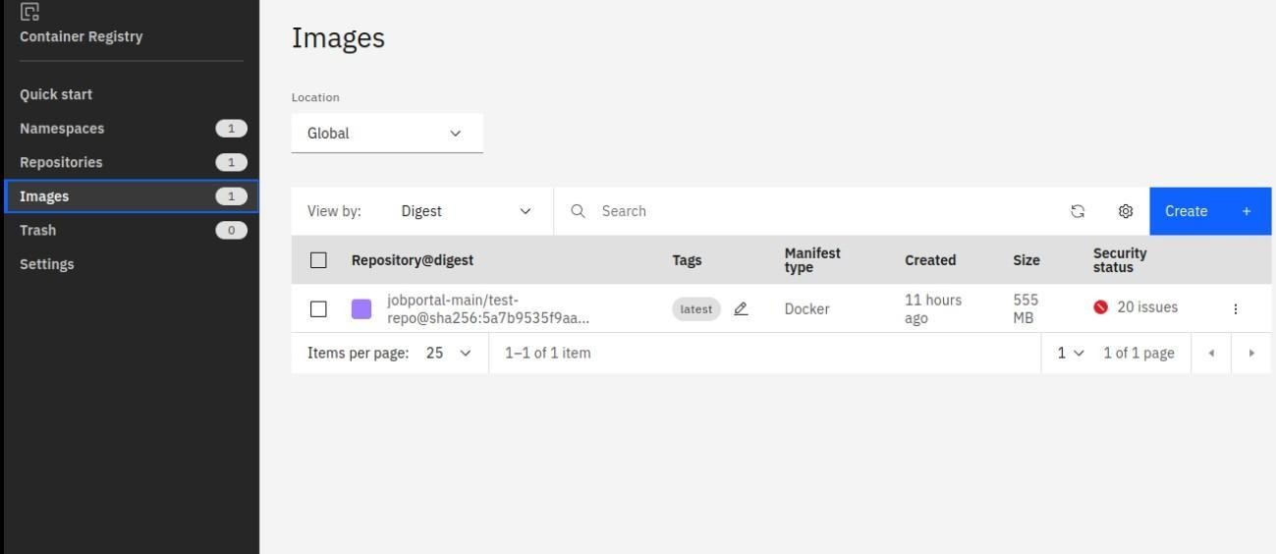

OUTPUT:

“HELLO WORLD”



# Question-4:

Create a Kubernetes cluster in IBM cloud and deploy helloworld image or jobportal image and also expose the same app to run in nodeport.

# Solution:

* Log into IBM cloud
* Create a kubernete
* Using IBM Cloud CLI, install the ks plugin in our system
* Create a cluster in the kubernetes
* Now, go to the kubernetes dashboard where we need to create a service based on a
* yml file (given below)
* In that file, we have to mention *which image we are going to use* and the *app name*
* Take the public IP address and Nodeport since we exposed the *flask app in nodeport*
* Finally, we got the url address where our flask app is hosted CODE:

apiVersion: v1 kind: Service metadata:

name: job-portal-app spec:

selector:

app: job-portal-app ports:

- port: 5000 type: NodePort

---

apiVersion: apps/v1 kind: Deployment

metadata:

name: job-portal-app labels:

app: job-portal-app spec:

selector: matchLabels:

app: job-portal-app replicas: 1 template:

metadata:

labels:

app: job-portal-app spec:

containers:

* name: job-portal-app image: image_name ports:
* containerPort: 5000 env:
* name: DISABLE_WEB_APP

value: "false"

